SWT 22022 – Practical for Internet Application Development
Department of Information and Communication Technology
Faculty of Technology
Lab sheet :20
Reg. Number: SEU/IS/20/ICT/084
Academic Year :2020/2021
Date: 2024.11.04
Practical No :21

Title:
- E – Commerce App (React) - I
Aims:
• Implement a ReactJS frontend application
Tasks:
• Create a New Project
• Install Necessary Packages
• Implement Components
• Integrate Components into the Page
Activities :
1. Create new project named “e-commerce-app”
2. Install Bootstrap
npm install bootstrap
npm install react-bootstrap bootstrap
3. Install react-route-dom
npm install react-router-dom
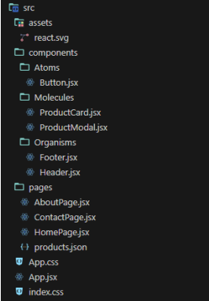
4. Create folder structure as follows

5. Implement Footer.jsx

import { Navbar, Container } from "react-bootstrap";
const Footer = () => {
return (
<Navbar bg="dark" variant="dark" fixed="bottom">
<Container>
<p className="text-white">Copyright &copy; 2024 My E-commerce App</p>
</Container>
</Navbar>
);
};
export default Footer;

6. Implement Header.jsx

import { Navbar, Container, Nav } from 'react-bootstrap';
import { Link } from 'react-router-dom';
const Header = () => {
return (
<Navbar bg="dark" variant="dark" fixed='top'>
<Container>
<Navbar.Brand href="#home">My E-commerce App -Admin</Navbar.Brand>
<Nav>
<Nav.Link as={Link} to="/">Products</Nav.Link>
<Nav.Link as={Link} to="/about">About</Nav.Link>
<Nav.Link as={Link} to="/contact">Contact</Nav.Link>
</Nav>
</Container>
</Navbar>
);
};
export default Header;

7. Implement ProductCard.jsx

import Card from 'react-bootstrap/Card';
const ProductCard = ({ product }) => {
return (
<Card>
<Card.Img variant="top" src={product.image} />
<Card.Body>
<Card.Title>{product.name}</Card.Title>
<Card.Text>{product.description}</Card.Text>Card.Text>${product.price}</Card.Text>
</Card.Body>
</Card>
);
};
export default ProductCard;

8. Implement ProductModal.jsx

import { useState } from "react";
import { Button, Modal, Form } from "react-bootstrap";

const ProductModal = ({ show, onHide, onSubmit, initialProduct }) => {
const [formData, setFormData] = useState(
initialProduct || {
name: "",
description: "",
price: "",
}
);

const handleChange = (e) => {
setFormData({ ...formData, [e.target.name]: e.target.value });
};

const handleSubmit = (e) => {
e.preventDefault();
onSubmit(formData);
onHide();
};

return (
<Modal show={show} onHide={onHide}>
<Modal.Header closeButton>
<Modal.Title>initialProduct ? "Edit Product" : "Add Product"}</Modal.Title>
</Modal.Header>
<Modal.Body>
<Form onSubmit={handleSubmit}>
<Form.Group controlId="formProductName">
<Form.Label>Product Name</Form.Label>
<Form.Control type="text" name="name" placeholder="Enter product name" value={formData.name} onChange={handleChange} required />
</Form.Group>
<Form.Group controlId="formProductDescription">
<Form.Label>Product Description</Form.Label>
<Form.Control as="textarea" name="description" placeholder="Enter product description" value={formData.description} onChange={handleChange} />
</Form.Group>
<Form.Group controlId="formProductPrice">
<Form.Label>Product Price</Form.Label>
<Form.Control type="number" name="price" value={formData.price} onChange={handleChange} required/>
</Form.Group>
</Form>
</Modal.Body>
<Modal.Footer>
<Button variant="secondary" onClick={onHide}>Close</Button>
<Button variant="primary" onClick={handleSubmit}>{initialProduct ? "Save Changes" : "Add Product"}</Button>
</Modal.Footer>
</Modal>
);
};

export default ProductModal;

9. Implement AboutPage.jsx
import Header from '../components/Organisms/Header';
import Footer from '../components/Organisms/Footer';
const AboutPage = () => {
return (
<>
<Header />
<div className="mx-5">
<h1>About Us</h1>
<p>Lorem ipsum dolor sit amet, consectetur adipiscing elit, sed do eiusmod tempor incididunt ut labore et dolore magna aliqua. Ut enim a minim veniam, quis nostrud exercitation ullamco laboris nisi ut aliquip ex ea commodo consequat. Duis aute irure dolor in reprehenderit in voluptate velit esse cillum dolore eu fugiat nulla pariatur. Excepteur sint occaecat cupidatat non proident, sunt in culpa qui officia deserunt mollit anim id est laborum. </p>
<p><strong>Our Mission:</strong> To provide high-quality products and exceptional customer service.</p>
<p><strong>Our Vision:</strong> To be the leading e-commerce platform in the industry.</p>
</div>
<Footer />
</>
);
};

export default AboutPage;
10. Implement ContactPage.jsx
11. Implement HomePage.jsx
import Header from "../components/Organisms/Header";
import Footer from "../components/Organisms/Footer";
import ProductCard from "../components/Molecules/ProductCard";
import productsData from "./products.json";
import { useState } from "react";
import { Button } from "react-bootstrap";
import ProductModal from "../components/Molecules/ProductModal";
const HomePage = () => {
const [showProductModal, setShowProductModal] = useState(false);
const [currentProduct, setCurrentProduct] = useState(null);
const handleAddProduct = () => {
setCurrentProduct(null);
setShowProductModal(true);
};
const handleEditProduct = (product) => {
setCurrentProduct(product);
setShowProductModal(true);
};
const handleProductSubmit = (productData) => {
setShowProductModal(false);
};
return (
<>
<Header />
<div className="mt-5">
<Button onClick={handleAddProduct}>Add Product</Button>
<ProductModal show={showProductModal} onHide={() => setShowProductModal(false)} onSubmit={handleProductSubmit} initialProduct={currentProduct} />
<h1 className="text-center mt-4">All Products</h1>
<div className="row mb-3">{productsData.map((product) => (
<div className="col-md-3 mb-3" key={product.id}>
<ProductCard product={product} />
<Button onClick={() => handleEditProduct(product)}className="mt-2">Edit Product</Button>
</div>
))}</div>
</div>
<Footer />
</>
);
};
export default HomePage;

12. Implement App.jsx
import { BrowserRouter as Router, Routes, Route } from 'react-routerdom';
import HomePage from './pages/HomePage';
import AboutPage from './pages/AboutPage';
import ContactPage from './pages/ContactPage';
import "./App.css";
const App = () => {
return (
<Router>
<Routes>
<Route path="/" element={<HomePage />} />
<Route path="/about" element={<AboutPage />} />
<Route path="/contact" element={<ContactPage />} />
</Routes>
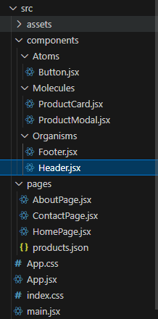
</Router>
);
};
export default App;

ProductCard.jsx
/* eslint-disable react/prop-types */
import Card from 'react-bootstrap/Card';
// import Button from 'react-bootstrap/Button';
const ProductCard = ({ product }) => {
return (
<Card>
<Card.Img variant="top" src={product.image} />
<Card.Body>
<Card.Title>{product.name}</Card.Title>
<Card.Text>{product.description}</Card.Text>
<Card.Text>${product.price}</Card.Text>
{/* <Button variant="primary">Add to Cart</Button> */}
</Card.Body>
</Card>
);
};

export default ProductCard;

ProductModal.jsx
/* eslint-disable react/prop-types */
import { useState } from "react";
import { Button, Modal, Form } from "react-bootstrap";

const ProductModal = ({ show, onHide, onSubmit, initialProduct }) => {
const [formData, setFormData] = useState(
initialProduct || {
name: "",
description: "",
price: "",
// ... other fields
}
);

const handleChange = (e) => {
setFormData({ ...formData, [e.target.name]: e.target.value });
};

const handleSubmit = (e) => {
e.preventDefault();
onSubmit(formData);
onHide();
};

return (
<Modal show={show} onHide={onHide}>
<Modal.Header closeButton>
<Modal.Title>
{initialProduct ? "Edit Product" : "Add Product"}
</Modal.Title>
</Modal.Header>
<Modal.Body>
<Form onSubmit={handleSubmit}>
<Form.Group controlId="formProductName">
<Form.Label>Product Name</Form.Label>
<Form.Control
type="text"
placeholder="Enter product name"
value={formData.name}
onChange={handleChange}
required
/>
</Form.Group>
{/* Add more form fields for description, price, etc. */}
</Form>
</Modal.Body>
<Modal.Footer>
<Button variant="secondary" onClick={onHide}>
Close
</Button>
<Button variant="primary" type="submit">
{initialProduct ? "Save Changes" : "Add Product"}
</Button>
</Modal.Footer>
</Modal>
);
};

export default ProductModal;

Footer.jsx
import { Navbar, Container } from "react-bootstrap";

const Footer = () => {
return (
<Navbar bg="dark" variant="dark" fixed="bottom">
<Container>
<p className="text-white">Copyright &copy; 2024 My E-commerce App</p>
</Container>
</Navbar>
);
};

export default Footer;

Header.jsx
import { Navbar, Container, Nav } from 'react-bootstrap';
import { Link } from 'react-router-dom';

const Header = () => {
return (
<Navbar bg="dark" variant="dark" fixed='top'>
<Container>
<Navbar.Brand href="#home">My E-commerce App - Admin</Navbar.Brand>
<Nav>
<Nav.Link as={Link} to="/">Products</Nav.Link>
<Nav.Link as={Link} to="/about">About</Nav.Link>
<Nav.Link as={Link} to="/contact">Contact</Nav.Link>
</Nav>
</Container>
</Navbar>
);
};

export default Header;

AboutPage.jsx
import Header from '../components/Organisms/Header';
import Footer from '../components/Organisms/Footer';

const AboutPage = () => {
return (
<>
<Header />
<div className="mx-5">
<h1>About Us</h1>
<p>
Lorem ipsum dolor sit amet, consectetur adipiscing elit, sed do
eiusmod tempor incididunt ut labore et dolore magna aliqua. Ut enim ad
minim veniam, quis nostrud exercitation ullamco laboris nisi ut
aliquip ex ea commodo consequat. Duis aute irure dolor in
reprehenderit in voluptate velit esse cillum dolore eu fugiat nulla
pariatur. Excepteur sint occaecat cupidatat non proident, sunt in
culpa qui officia deserunt mollit anim id est laborum.
</p>
<p>
<strong>Our Mission:</strong> To provide high-quality products and
exceptional customer service.
</p>
<p>
<strong>Our Vision:</strong> To be the leading e-commerce platform in
the industry.
</p>
</div>
<Footer />
</>
);
};

export default AboutPage;

ContactPage.jsx
import Header from "../components/Organisms/Header";
import Footer from "../components/Organisms/Footer";

const ContactPage = () => {
return (
<>
<Header />
<div className="mx-5">
<h1>Contact Us</h1>
<p>
<strong>Have a question or need assistance?</strong> Please feel free
to contact us using the information below.
</p>

<p>
<strong>Address:</strong>
Your Company Address
</p>
<p>
<strong>Phone Number:</strong>
(123) 456-7890
</p>
<p>
<strong>Email:</strong>
your_email@example.com
</p>
</div>
<Footer />
</>
);
};

export default ContactPage;

HomePage.jsx
import Header from "../components/Organisms/Header";
import Footer from "../components/Organisms/Footer";
import ProductCard from "../components/Molecules/ProductCard";
import productsData from "./products.json";
import { useState } from "react";
import { Button } from "react-bootstrap";
import ProductModal from "../components/Molecules/ProductModal";

const HomePage = () => {
const [showProductModal, setShowProductModal] = useState(false);
const [currentProduct, setCurrentProduct] = useState(null);

const handleAddProduct = () => {
setCurrentProduct(null);
setShowProductModal(true);
};

const handleEditProduct = (product) => {
setCurrentProduct(product);
setShowProductModal(true);
};

const handleProductSubmit = (productData) => {
// Handle the submitted product data (e.g., send it to the backend)
setShowProductModal(false);
// Update the product list or perform other actions
};

return (
<>
<Header />
<div className="mt-5">
<Button onClick={handleAddProduct}>Add Product</Button>
<ProductModal
show={showProductModal}
onHide={() => setShowProductModal(false)}
onSubmit={handleProductSubmit}
initialProduct={currentProduct}
/>
<h1 className="text-center mt-4">All Products</h1>
<div className="row mb-3">
{productsData.map((product) => (
<div className="col-md-3 mb-3" key={product.id}>
<ProductCard product={product} />
<Button onClick={() => handleEditProduct(product)} className="mt-2">
Edit Product
</Button>
</div>
))}
</div>
</div>
<Footer />
</>
);
};

export default HomePage;

products.json
[
{
"id": 1,
"name": "Product 1",
"description": "This is the first product.",
"image": "/card.png",
"price": 19.99
},
{
"id": 2,
"name": "Product 2",
"description": "This is the second product.",
"image": "/card.png",
"price": 29.99
},
{
"id": 4,
"name": "Product 4",
"description": "This is the third product.",
"image": "/card.png",
"price": 39.99
},
{
"id": 5,
"name": "Product 5",
"description": "This is the fourth product.",
"image": "/card.png",
"price": 39.99
},
{
"id": 6,
"name": "Product 6",
"description": "This is the fifth product.",
"image": "/card.png",
"price": 39.99
}
]

App.jsx

import { BrowserRouter as Router, Routes, Route } from 'react-router-dom';
import HomePage from './pages/HomePage';
import AboutPage from './pages/AboutPage';
import ContactPage from './pages/ContactPage';
import "./App.css";

const App = () => {
return (
<Router>
<Routes>
<Route path="/" element={<HomePage />} />
<Route path="/about" element={<AboutPage />} />
<Route path="/contact" element={<ContactPage />} />
</Routes>
</Router>
);
};

export default App;

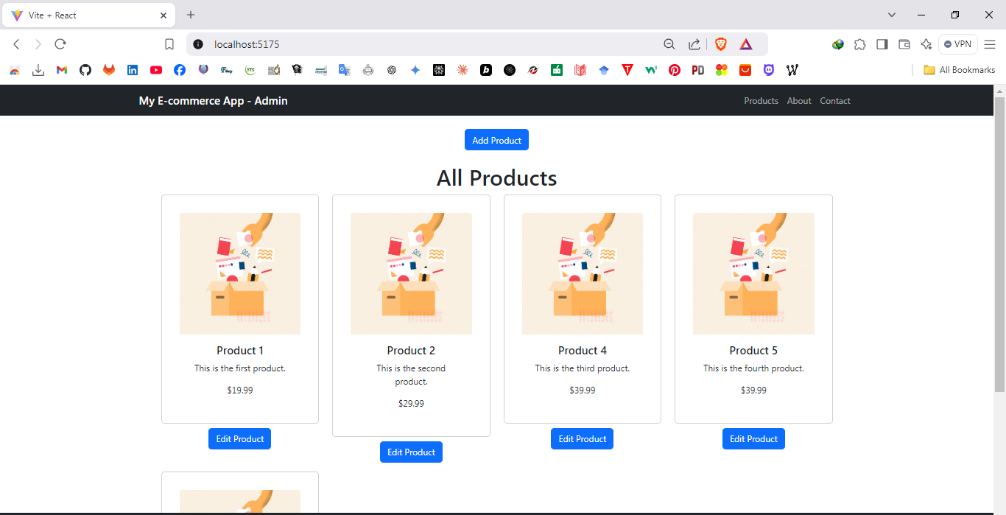

Discussion:
- In this lab practical session, I gained hands-on experience in building dynamic applications with React. The session's main objective was to create a dynamic list using useState, which helped me manage the state of items in the list efficiently. I also explored the power of the Context API, which allowed me to share data across components without having to pass props at every level, thus making the code more maintainable and scalable. Another key part of the session was setting up React Router for client-side routing, enabling smooth navigation between different pages without reloading the entire application. Additionally, I used Axios to fetch data from an external API, which allowed me to integrate real-time data into my app. Overall, this session gave me a solid understanding of core React concepts like state management, data sharing, routing, and API integration, which are essential for developing interactive and modern web applications.

